2016/17 candidate record form, production log
and assessment record

Level 3 Extended Project (7993)
Please attach the form to your candidate’s work and keep it at the centre or send it to the moderator as required. The declarations should be completed as indicated.

Centre number |  | Centre name
13327 |  | ILFORD COUNTY HIGH SCHOOL

Candidate number |  | Candidate’s full name
3090 |  | ROHIT PRASAD

Work submitted for assessment must be the candidate’s own. If candidates copy work, allow candidates to copy from them, or cheat in any other way, they may be disqualified.

Candidate declaration
Have you received help/information from anyone other than subject teacher(s) to produce this work?

☒ No ☐ Yes (give details below or on a separate sheet if necessary).

Click here to enter text.

Please list below any books, leaflets or other materials (for example DVDs, software packages, internet information) used to complete this work not acknowledged in the work itself. Presenting materials copied from other sources without acknowledgement is regarded as deliberate deception.

Click here to enter text.

From time to time we use anonymous examples of candidates’ work (in paper form and electronically) within our guidance materials to illustrate particular points. If your work appears in AQA materials in this context and you object to this, please contact us and we will remove it on reasonable notice.

I have read and understood the above. I confirm I produced the attached work without assistance other than that which is acceptable under the scheme of assessment.

Candidate signature. | Date | Click here to enter a date.

Supervisor declaration
I confirm the candidate’s work was conducted under the conditions laid out by the specification. I have authenticated the candidate’s work and am satisfied, (to the best of my knowledge) that the work produced is solely that of the candidate.

Supervisor signature. | Date | Click here to enter a date.

Submission checklist

To be completed by the supervisor

Extended Project working title | Click here to enter text.

Extended Project final title | Click here to enter text.

Form of project
☒ | Either | written report
☐ | Or | Click here to enter text. | and accompanying written report

Is this project part of a group project?
☒ | No
☐ | Yes | If ‘Yes’, give brief details Click here to enter text.

Please note that failure to complete or submit a compulsory element may result in a mark of zero being awarded.

Select/tick | Items that must be included | Notes
☐ | - A signed and completed Candidate record form, production log and assessment record | This document. All pages must be completed.
☐ | - Research based written report | If the project product is an artefact or a production, an accompanying research based written report is also required.
☐ | - Evidence of the project product | Eg photographs of artefact, investigation or production; a piece of creative writing (artefact); research based written report.
☐ | - Evidence of a presentation within the production log | Presentation on the project process. Where the project product is itself a presentation (for a specified audience), a presentation on the project process must also be delivered to a non-specialist audience

The taught skills element

To be completed by the supervisor

Outline details of taught skills
Record here details of relevant skills taught in a class/group and details of relevant skills taught individually to this candidate as described in the specification. Continue on a separate sheet if necessary.
Click here to enter text.

Record of marks

To be completed by the supervisor
Marks must be awarded in accordance with the instructions and criteria in the specification.

Summary information to show how the marks have been awarded should be given in the spaces below in addition to comments in other pages of this document and any supporting information in the form of annotations on the candidate’s work.

Skill area | Maximum  mark | Mark  awarded | Supervisor’s supporting statement
- Manage | 10 | Click. | Click here to enter text.
- Use resources | 10 | Click. | Click here to enter text.
- Develop and realise | 20 | Click. | Click here to enter text.
- Review | 10 | Click. | Click here to enter text.
Total mark | 50 | Click.

Supervisor’s concluding comments
Click here to enter text.

Internal moderation comments if appropriate
Click here to enter text.

Supervisor declaration
I confirm that no work assessed for the award of the marks above is also to be submitted, or has been submitted, for any other accredited qualification(s).

Supervisor signature. | Date | Click here to enter a date.

Record of initial ideas

To be completed by the candidate
This page records initial meeting(s) with your supervisor to agree your project ideas. Additional pages can be submitted if more than one idea has been explored.

My idea(s) for topic/title
Question: How can machine learning algorithms be used to achieve predictive modelling of data?
The project would entail an investigation of several machine learning algorithms upon a variety of datasets. Procedure would include research into algorithms, identification of specific problems through inspection of datasets, implementation of algorithm and evaluation of the algorithm performance based on output accuracy.
My ideas for research and development of my project
- The initial, heuristic resource to provide gentle, obstacle free introduction to machine learning would be educative blog posts by a recognised machine learning practitioner (Jason Brownlee - http://machinelearningmastery.com/) One of his published e-books (Master Machine Learning Algorithms) would provide an introduction to the algorithms I intend to research. (https://machinelearningmastery.com/master-machine-learning-algorithms/)
- Sample datasets that are sufficiently sized can be obtained from the UC Irvine Machine Learning Repository (http://archive.ics.uci.edu/ml/datasets.html) These will be used as training data for the algorithms I intend to implement.
- To further research algorithms, I can use the authoritative resources (textbooks) available at UCL Library. I can also find existing implementations of algorithms I intend to discuss, on Github (a platform where developers can share open source code to manage development lifecycles). I will also use seminal resources such as conference papers and journal articles.
- Each algorithm I investigate will involve detail on its research, design (including inspection of the dataset), implementation and evaluation.
My summary of the comments and advice from my supervisor
- Investigation of machine learning algorithms is beyond A Level standard and will be sufficiently complex, interesting and feasible within the timescale.
- The initial question doesn’t provide any leads for a specific end product. The question is too broad and it will be difficult to evaluate whether the question has been answered at the end of the project regardless of its content.
- A way in which the question can be improved will be to compare the effectiveness of machine learning algorithms of a specific domain. To compare the effectiveness, I can use the accuracy evaluations I write up for each algorithm.
- To ensure that the comparison remains fair, only one dataset should be used. The benefits of this will be that I will not have to spend time understanding new datasets, which is not an element of my question, as it is based purely on algorithms.
Modifications I have made as a result of my discussion with my supervisor
I have changed the question to allow for a comparison of the effectiveness of machine learning algorithms, and limited the number of datasets used, to just one. Since some algorithms cannot be compared directly, I have also limited the domain of algorithms I will research to ‘supervised’.
How do popular supervised machine learning algorithms compare in their efficacy for a given dataset?

 | Date | 13 July 2016

Part A: Candidate proposal

To be completed by the candidate

Working title of my Extended Project.
Present the topic to be researched in the form of a short statement/question/hypothesis with clear focus.
How do popular supervised machine learning algorithms compare in their efficacy for a given dataset?

- my initial resources will be
I will initially use an e-book by Jason Brownlee - https://machinelearningmastery.com/master-machine-learning-algorithms/ to gain an introduction to machine learning. There are also several heuristic resources on the blog which will aid me in kick-starting this machine learning project.
- the courses of study or area(s) of personal interest to which the topic relates
- Computer Science (Artificial Intelligence).
- Machine Learning
- Statistics
- my intended product
A report detailing the research, design, implementation and evaluation of 4 supervised machine learning algorithms, ending with a comprehensive comparison of their performance, accuracy and bias-variance trade off. In addition to the report I will be producing, as part of the project, implementations of the algorithms on the dataset in spread sheeting software/python code.

Provide details of the courses that you are currently studying

Qualification type | Awarding body & subject
eg A-level, Modern Apprenticeship, BTEC | eg AQA Mathematics, OCR Computing, WJEC English
A Level | Edexcel Mathematics
A Level | Edexcel Further Mathematics
A Level | AQA Physics

Qualification type | Awarding body & subject
A Level | AQA Computer Science
Click to enter text. | Click here to enter text.
Click to enter text. | Click here to enter text.
Click to enter text. | Click here to enter text.
Click to enter text. | Click here to enter text.

Notice to candidate You must not take part in any unfair practice in the preparation of project work required for assessment and you must understand that to present material copied directly from any book or any other sources without acknowledgement will be regarded as deliberate deception. If you use or attempt to use any unfair practice you will be reported to AQA and you may be disqualified from all subjects.

Candidate declaration
I certify that I have read and understood AQA’s Regulations relating to unfair practice as set out in the notice to candidates above.

Candidate signature. | Date | 13 July 2016

Part B: Supervisor’s comments on candidate proposal

To be completed by the supervisor
Please comment below on the validity and feasibility of the candidate proposal (Part A) as an Extended Project

 | Supervisor’s comments
Indicate the relation to, and development/extension outside of, the main course(s) of study or interest | Click here to enter text.
Comment on the suitability of the proposed initial sources and research base | Click here to enter text.
Confirm that the project is feasible in the proposed timescale and/or indicate any potential difficulties that may prevent the candidate from meeting the assessment objectives | Click here to enter text.

Indicate the expected format of the project product that will be submitted for assessment
☒ Research based written report
☐ Artefact (for example prototype, model, artwork, scientific investigation, creative writing) plus written report

Is the project a contribution to a group exercise? ☐ YES ☒ NO
If Yes, confirm that there is a defined individual contribution by the candidate ☐ YES ☐ NO

List the other group members below.

Candidate No. Click. | Candidate Name Click here to enter text.
Candidate No. Click. | Candidate Name Click here to enter text.
Candidate No. Click. | Candidate Name Click here to enter text.

Supervisor signature. | Date | Click here to enter a date.

Part C: Centre coordinator’s approval of candidate proposal

Supervisor’s name
Click here to enter text.

To be completed by the centre coordinator
If you are acting as both the Centre coordinator and the supervisor, please seek counter signature from a senior colleague

Centre coordinator’s comments on the feasibility and acceptability of the proposal (parts A & B) as an Extended Project
Click here to enter text.

☐ | Approved | ☐ | Approved subject to the implementation of  the centre coordinator’s recommendations | ☐ | Resubmission required

Centre coordinator’s name
Click here to enter text.

Centre coordinator signature. | Date | Click here to enter a date.

Planning review

To be completed by the candidate
This page records your outline plan once your proposal has been approved.

My next steps in planning, researching and deadlines that I will set myself. What I intend to do, by when, what resources I will use and how I will implement the recommendations of the centre co-ordinator (where appropriate).
My deadlines have been recorded, in detail, in my intended timeline for the project drawn up in the form of a Gantt chart (see page 11), and also in a tabular form highlighting intended start dates and finish dates for each phase of the project (see page 10). As a summary, I intend to dedicate 6 weeks to researching my project, starting from shortlisting which algorithms to compare and then moving on to choose the dataset I will implement the algorithms on. For 3 of the 6 weeks I will research the algorithms I have chosen and assess their complexity and feasibility to implement, and then narrow the 5 to 6 chosen to 4 final algorithms. The research phase is expected to last until mid to late October, at which point I will conduct the mid project review meeting with my supervisor and make changes, if any, to the question. Following the mid project review, I will work on the product, first implementing each algorithm and then evaluating it. Once all 4 have been implemented and evaluated, I will conclude the project report by comparing the 4 algorithms with each other. The writing of the project report is expected to last until the end of the year (2016/2017). After a short break, I will begin working on the presentation which will continue until January/February at which point I will be ready to present. Currently, the next phase in my project is to choose the dataset and evaluate it for use in this project. I have achieved my first milestone (finalised 5-6 algorithms) on time. I will use the UCI Machine Learning Repository - http://archive.ics.uci.edu/ml/ to find a dataset. Following the dataset evaluation, I will begin to research the algorithms using Jason Brownlee’s ‘Machine Learning Mastery’ and Stephen Marsland’s ‘Machine Learning: An Algorithmic Perspective’.

My summary of the comments and advice from my supervisor
Overall, the project plan is detailed and the timescales of each phase are feasible. The method I am using to complete the project (researching algorithms, implementing and evaluating each algorithm in turn and finally comparing the algorithms) is logically sound and will allow me to complete the project report to a high standard. However, since my project is one in which a great deal of focus will be placed on implementing the algorithms as well as comparing them, my supervisor made the point that the question does not reflect the implementation aspect very well. By making an appropriate change to the question, a lot more of my project report will become relevant to the question, because currently only the conclusion is relevant to the question.
Modifications I have made as a result of my discussion with my supervisor and/or the comments from my centre coordinator
Following the comments of my supervisor regarding the implementation aspect of my project, I made the appropriate change to the question.
Before: How do popular supervised machine learning algorithms compare in their efficacy for a given dataset?

After: How do popular supervised machine learning algorithms compare in their implementation and efficacy for a given dataset?

My project report will place focus on the intricacies in implementing each of the 4 algorithms I will choose, and compare them by the complexities in implementing them as well as their efficacy.

 | Date | 16 September 2016
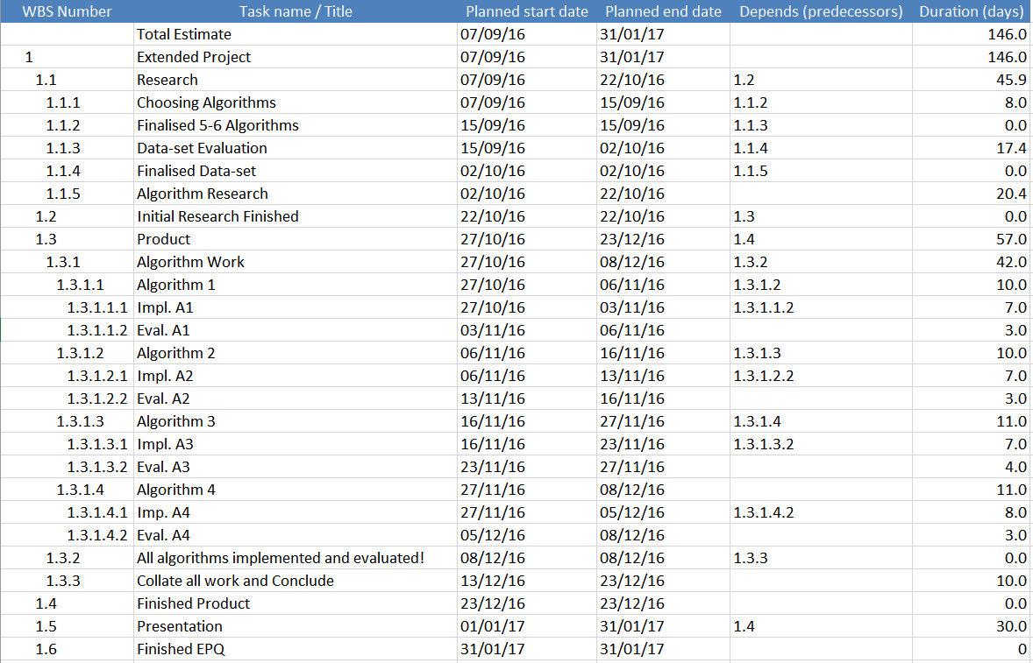
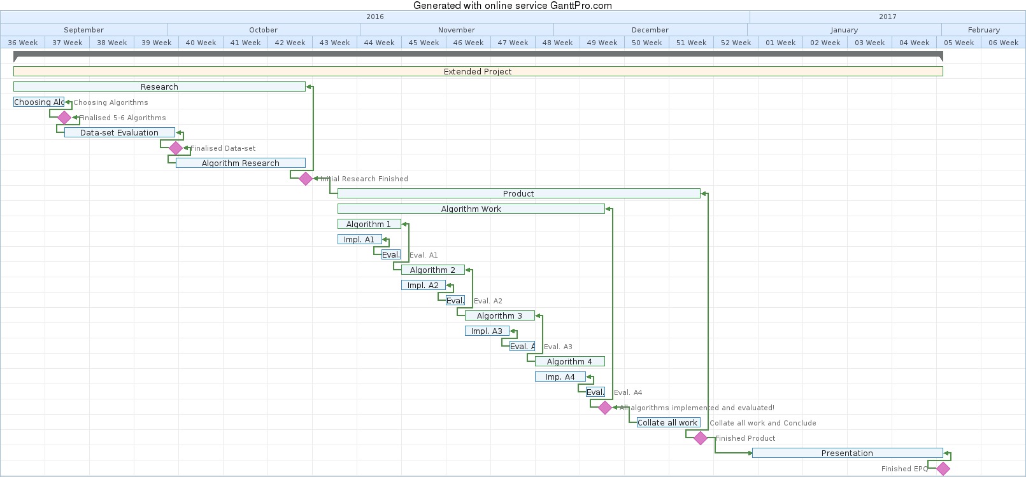
Mid-project review

To be completed by the candidate
This page records your outline plan when you have completed your research.

Is my project following my original plan? How has my plan developed?
The project is mostly following the original plan, with the method in which I am completing the report being the same. I am still going to implement and evaluate algorithms sequentially, before concluding with a detailed comparison. All the deadlines are being met on time. As per the initial project plan (page 11), I have completed the research phase of the project, and decided upon the algorithms I will implement and compare. Following my research, I found that classification algorithms are the most feasible to learn and implement within the time available, so my entire project report will be centred around the process of classification. Additionally, the dataset I chose is about tennis statistics and I have decided to use the algorithms to predict the winner of a tennis match. I plan to evaluate the algorithms’ performance on 4 different attributes from the dataset; break points won, unforced errors, aces and winners. This will make my project report more reliable as a paper comparing the performance of machine learning algorithms, since I repeated my experiments for different sets of data.
My summary of the comments and advice from my supervisor
My supervisor suggested that I alter the question to reflect the type of algorithms being used; classification algorithms. This will allow my project report to be more relevant to the question. Additionally, he advised that I focus on comparing three algorithms in greater detail rather than four. Reasons for this were that I would be able to go into greater depth with three algorithms, and the comparisons in the conclusion will be easier to organise. Moreover, it will be more feasible to complete within the timescale if I have to implement one less algorithm since the fourth algorithm isn’t adding any value to the project report itself. He also suggested that I precede each algorithm’s implementation with a section highlighting some of its underlying principles to allow for a better understanding of how it works. This will help me evaluate its complexities in the evaluation.
Modifications I have made as a result of my discussion with my supervisor at this stage
I have changed the title following my supervisor’s advice, by adding the word classification to make it more specific. I have also decided to begin each algorithm’s section in the project report with some research about it, explaining some of the core mathematical ideas that underpin its function. My structure for the sections for the algorithms will be ‘research’, ‘implementation’ and ‘evaluation’. Additionally, I have decided to focus on three machine learning algorithms instead of the initially planned four following my supervisor’s comments. I have adjusted my project plan accordingly to accommodate for this change in the objectives.
My final title and agreed form of project product

How do popular supervised machine learning classification algorithms compare in their implementation and efficacy for a given dataset?

I will be writing a research based written report of a scientific investigation, the length of which will be at least 5000 words.

My planned next steps to complete my project
I plan to finish the algorithm research phase, and then following my modifications made in the mid-project review I will select three algorithms to focus on for the report based on their difficulty to implement, how they differ from each other and also their suitability for supervised classification. Next, I will begin to code the algorithms starting in November, implementing and evaluating each in turn. I plan to finish this phase by the end of November. After that, I will write a conclusion collating all the results of the experiments I did and analysing them comparatively in depth – I aim to finish the project report by mid-December. Finally, I will work on planning and designing my presentation starting in the new year, and finishing by the end of January.

 | Date | 19 October 2016

Project product review

To be completed by the candidate
This page records the (near) completion of your project product. Outline the successes, failures, additions and/or changes you made as you followed the plan in your mid-project review

Did my project follow my revised plan (from the mid-project review)?
The project followed my plan exactly from the mid project review and most deadlines were met. I used the updated project timeline (see page 14) to keep track of the planned start and end dates for milestones (highlighted green) and tasks. Over the course of my project, I logged the dates at which the tasks actually started and finished.
I made a few changes to the way I implemented each algorithm. Instead of modelling it in a spreadsheet only, which was my initial plan, I increased the reusability by writing all the algorithms in python. This increased the speed at which I could test the algorithms on different datasets greatly as the algorithm was written in its general form and could be applied to any set of data by changing one line of code. Thus, I was able to cut down on the time taken to evaluate any algorithm’s performance.
However, I was not able to implement one of my algorithms - ‘Naïve Bayes’ on the dataset that I chose because of issues I did not foresee in the research phase. From further research, however, I was able to code a variant of Naïve Bayes – ‘Gaussian Naïve Bayes’ correctly. This did not impact the quality of my report since I found a suitable substitute.

My summary of the comments and advice from my supervisor at this final stage
My project report is scientifically sound, and the conclusions that I have made are valid. It is at an acceptable level of detail, and is structured excellently. My selection of sources in the report are all relevant to the question being discussed have been cited well using the Harvard Referencing system. However, an area where the report currently lacks is the evaluation of the sources for reliability. Although I have a large variety of resources, I have used them all without giving any importance to their reliability or even validity and have assumed that they are trustworthy.
Additionally, a second point made by my supervisor was to append all the algorithms that I wrote to the appendix. It would allow a reader of my report to inspect my code completely rather than in a collection of small chunks that I have currently presented it in. Moreover, this would allow a reader to run my programs using a python interpreter and see if they can reproduce my results thus making the paper more reliable as a whole.

Modifications I have made as a result of discussion with my supervisor at this final stage
Do I need to do anything else to complete my product?
I have added all 3 algorithms’ python code to the appendix as per my supervisor’s recommendation. This only enhances my project as a whole, and increases its reliability as readers can run these programs themselves to see if they can reproduce the results.
I plan to write short source evaluations for the main sources that I used the most and add these to the appendix as per my supervisor’s comments.

 | Date | 10 March 2017
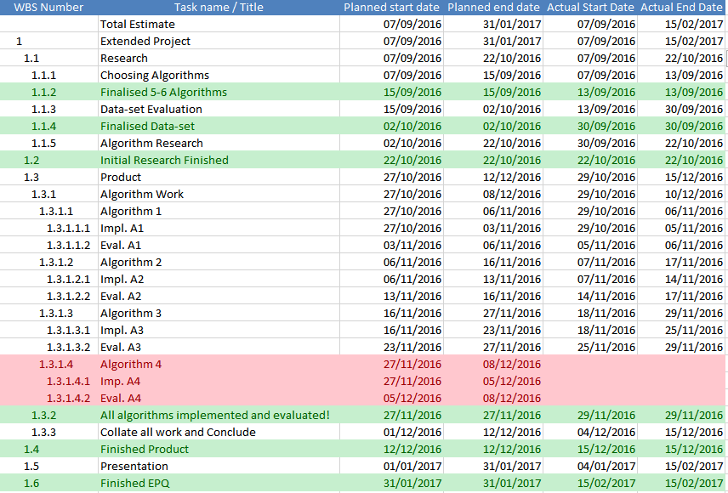

Presentation record part A

To be completed by the candidate
This page records your presentation and its preparation.

Planned format of my presentation (eg timing, audience, use of visual aids, slides, use of notes, etc.)
I plan to present for 25 minutes using an online presentation tool – www.slides.com. I found it to be slightly better than the other more mainstream tool such MS PowerPoint and Prezi because of the ease at which I could create graphics within the tool.
For the initial 2 minutes, I intend to discuss how the project question evolved from its initial question to where it is currently, discussing the reasons for which I made the changes. I will also explain the exact meaning of my question and what it entails, since it comprises much machine learning jargon.
For about 10 to 12 minutes, I intend to use simple graphs and worked through example to illustrate the machine learning process starting from data preparation to making predictions. I will explain all the algorithms that I used in a summary format as well.
For the final 10 minutes, I plan to cover the project process by talking about how I planned the project, how I went about researching my question, what resources I used, the strengths and weaknesses of my project and finally what I learnt from the extended project.
Additionally, I will be handing out a glossary to all the members of the audience with some key words that I might use during my presentation to aid in their understanding. Attached to the glossary will be some graphs that I will explain during my presentation, printed so that the audience can take a closer look. The presentation will be accessible for a non-specialist audience.
Planned content of my presentation
Slide 1 – Evolution of question, explaining reasoning for changes made. Ending the slide with the actual question and highlight key words to explain its meaning. Reinforce meaning with glossary sheet.
Slide 2 – Explain the aim with implementing all of these algorithms, mention the names of the algorithms being implemented.
Slide 3 - Explain classification with a simplified example and then make links to the actual dataset used. Explain properties of data such as separability and outliers.
Slide 4 – Explain the machine learning process. How data is prepared for an algorithm, how it is implemented and how it is evaluated. Make links to actual dataset used.
Slide 5 – Explain the first step of the machine learning process (data preparation). Use simple graphs and very little text.
Slide 6 – Explain the second step (training a model). Again, use simple graphs and transitioning animations to visually/intuitively explain how one of the three algorithms works.
Slide 7 – Explain the third step (making predictions and evaluation). Use same examples as slide 6.
Slide 8 – Analyse the results by showing a table of well each algorithm performed, and help the audience to understand the reasons for which some performed better than the others.
Slide 9 – Explain the initial sources used in research.
Slide 10 – Explain how each algorithm was researched by naming a source and discussing its credibility and usefulness.
Slide 11 – Talk about project’s strengths and weaknesses, bullet point arguments in a table on the slide.
Slide 12 – Talk about the challenges faced while conducting the projects.
Slide 13 – Shortly discuss things I have learnt and the significance of the project with respect to my choice of university course.

See the attached evidence of the highlights of the presentation slides or visit this URL to view the presentation as the audience saw it:

http://slides.com/rohitprasad/deck

Modifications I have made as a result of rehearsal and/or discussion with my supervisor
My supervisor suggested that I focus on just one of the algorithms that I used and try to explain that as simply as possible. Summarising all three algorithms was too much to absorb in 15 minutes and was not a good idea. Following his comments, I explained how only one algorithm worked using visual aids and simplified language in the presentation to outline the machine learning process. However, I ensured that I, at the very least, mentioned how I researched the other two algorithms since they formed a large portion of my project report.

 | Date | 10 March 2017

Presentation record part B

To be completed by the supervisor
Record and comment below on the delivery of the presentation

 | Supervisor’s record/comments
The nature of the audience (include numbers of staff, students and others present) | Click here to enter text.
The nature of the presentation (include use of notes, use of display items, and use of presentation software) | Click here to enter text.
Comment on the content and delivery of the presentation (for example clarity of ideas, structure of presentation, pace, engagement with audience) | Click here to enter text.
Comment on the response of the candidate to questions that demonstrated understanding and grasp of the project and/or its production. Give examples of questions asked and answers given. | Click here to enter text.

Supervisor signature. | Date | Click here to enter a date.

Summary and reflection

To be completed by the candidate
This page records your summary, reflection and evaluation when you have completed your project product and given your presentation.

Some questions you may wish to answer in this section include, what have I learned from completing this project? What new knowledge or expertise have I enjoyed or found valuable? What are the strengths and weaknesses of my project (including planning and organisation)? What skills have I improved? What changes would I make if I undertook such work again? What advice would I give to others undertaking such a project?
I have learned a great deal about my personal learning process as well as data science and machine learning. Initially finding the topic I chose extremely challenging to understand I was on the verge of changing the field completely. However, my fascination with machine learning allowed me to tackle the challenges as they came and spend hours trying to understand the basics of what I was researching. Through this continued persistence, I learned that I am able to understand concepts that initially seem incomprehensible with complete independence if I spend enough time. With respect to the topic I chose to research, I learned the general approach to take when implementing any machine learning algorithm starting from research and ending with evaluation – this will help me greatly at university when I learn this in greater detail. Strength of my project, in relation to what I learnt, are that I was able to understand exactly how the three algorithms worked and also generalise the algorithm’s implementation to any dataset and not just the dataset I used. A weakness, however, is that with each of the algorithms I was not able to understand their mathematical derivations. Several times, I had to make assumptions about how certain parts of the algorithm worked which created some gaps in understanding. The reason for this is that the mathematics used was too advanced and beyond my current ability – it required 3rd year degree level mathematics.

My planning for this project, in my opinion, was its most important aspect. I split the entire extended project into smaller chunks of work divided into 3 phases – research, product and presentation. This structure had many strengths. I was able to begin my project by spending time on understanding what I had to implement and gauging how difficult it could be before I actually had to do it. This allowed me to assess the project objectives’ feasibility more reliably in the planning review. Moreover, it allowed me to understand the dataset I was going to use extremely well making the ‘implementation’ sections easier and quicker. I split the ‘product’ phase into 4 sub phases – 3 sub phases for each algorithm and one final phase to conclude. The strength of this was that I was able to place full focus on single sub tasks and complete them with greater efficiency rather than attempt to solve problems with many tasks simultaneously which would be overwhelming. The last phase was the presentation phase in which I developed my visual aids and handouts – planning this into my timescale ensured that I completed it with sufficient time to spare to make amendments. By maintaining a project log, I was able develop the important practice of meeting deadlines. Having previously completed most of my projects by doing them in the last few days, I understood that the extended project would require strict deadlines if I was to have a chance at completing the project. Although I did not meet all my deadlines, in doing the project I was able to develop this skill and it will be of great use in the future. One of the weaknesses of my planning was that it did not allow for much break time between sub tasks and due to this, I was not able to perfect my algorithm write ups as I did them. This meant that I had to apply my finishing touches at the end of writing my project report, and by that time I had forgotten how some complicated aspects of the algorithms worked. This delayed the completion of the project report. Another weakness was that I did not plan to evaluate my sources, which again delayed the completion of the project.

Regarding my presentation, I felt there were several strengths and a few weaknesses. I spoke clearly for the most part and finished in exactly 25 minutes as planned. I engaged with the audience when appropriate and generally got good responses from them. The quality of questions I received reflected the fact that the audience did understand the technicalities of my project and I presented it with enough simplicity to be understood by a non-specialist audience. I answered the questions from supervisor in sufficient detail, often drawing on general knowledge of current events which highlighted the importance of machine learning in the real world. However, one of my weaknesses were that I overly stressed the project’s difficulty rather than highlighting my achievements. Although I was being completely honest, I did create a slightly negative view of my project. Additionally, I also forgot to mention some of the details I had initially planned to, on some of the slides. Although this was not noticeable from the perspective of the audience, I personally knew I had missed them. From this I learnt that I should either have a few cards to remind myself of what to say, or practice the presentation identically multiple times.

If I were to undertake a project like this again, I would spend a lot more time researching the project rather than writing the report. The research provides you with the basic prerequisites to be able to write a valid, high quality report and for this reason it is the most important phase. I found myself looking up lesser obvious aspects of my algorithms during their implementation because during the time I dedicated to research, I did not anticipate several problems that I faced later on. Additionally, in planning a project like this, I would separate each sub task by at least 2 days to provide some breathing room for adding finishing touches to individual sections. One of the strengths of my planning was that my report was mostly modular. There were 5 discrete sections and it was easier to gauge my progress in answering the question. My advice to others undertaking the extended project would be to split it up into modular subtasks, each independent of the others and set deadlines for the completion of each task. In doing so you will be more motivated to finish the extended project, as you will be able to clearly identify your progress in answering the question and also be able to manage the word count of the report with ease.

